Week 1

Program 1 (1)

Given below is a simple program written in C language.

Change the text in the code given below to make the program print “Hello C” instead of “Hello B”.

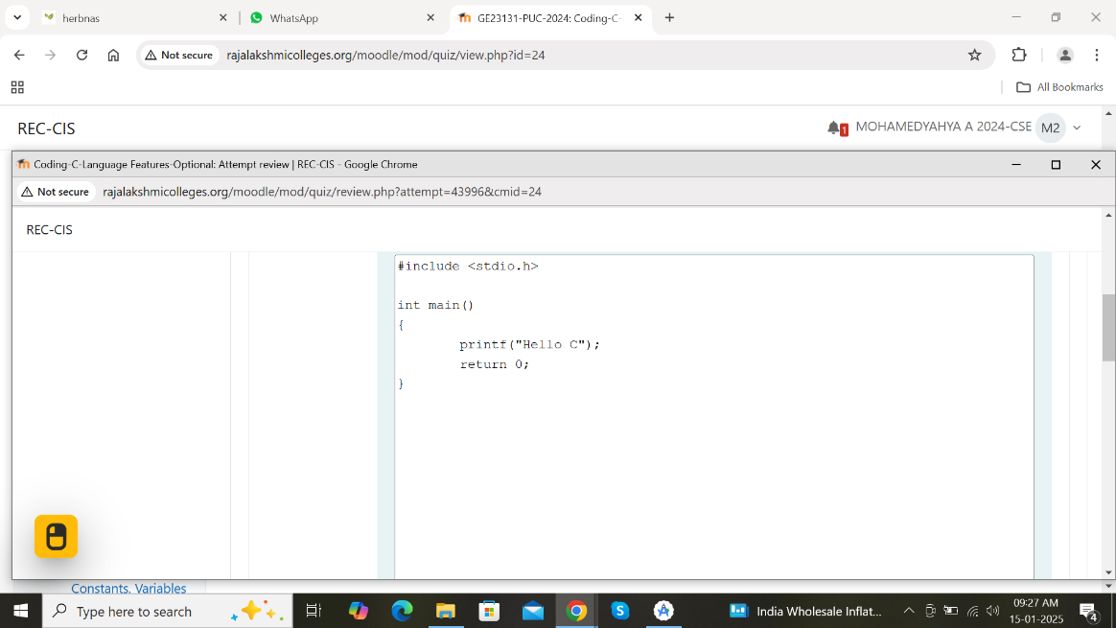

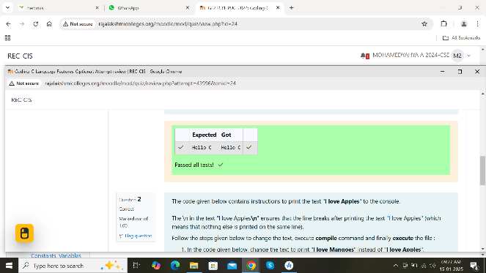

Program 1 (2)

The code given below contains instructions to print the text “I love Apples” to the console.

The \n in the text “I love Apples\n” ensures that the line breaks after printing the text “I love Apples” (which means that nothing else is printed on the same line).

Follow the steps given below to change the text, execute compile command and finally execute the file :

In the code given below, change the text to print “I love Mangoes” instead of “I love Apples”.

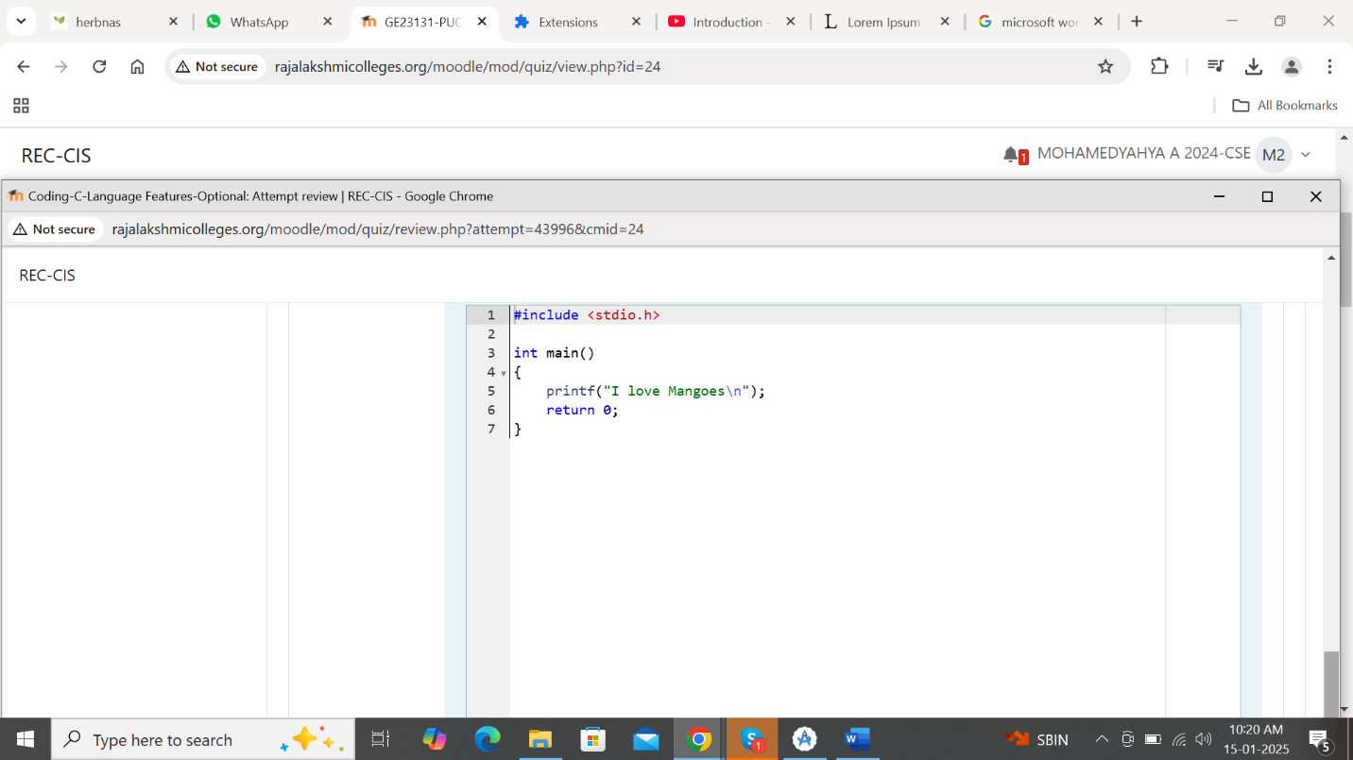

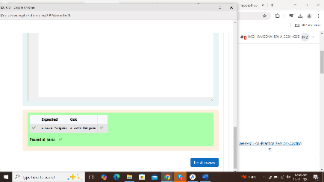Program 2(1)

Objective

This is a simple challenge to help you practice printing to stdout.

We’re starting out by printing the most famous computing phrase of all time! In the editor below, use either printf or cout to print the string Hello, World! To stdout.

Input Format

You do not need to read any input in this challenge.

Output Format

Print Hello, World! To stdout.

Sample Output

Hello, World!

Answer: ( penalty regime: 0 %)

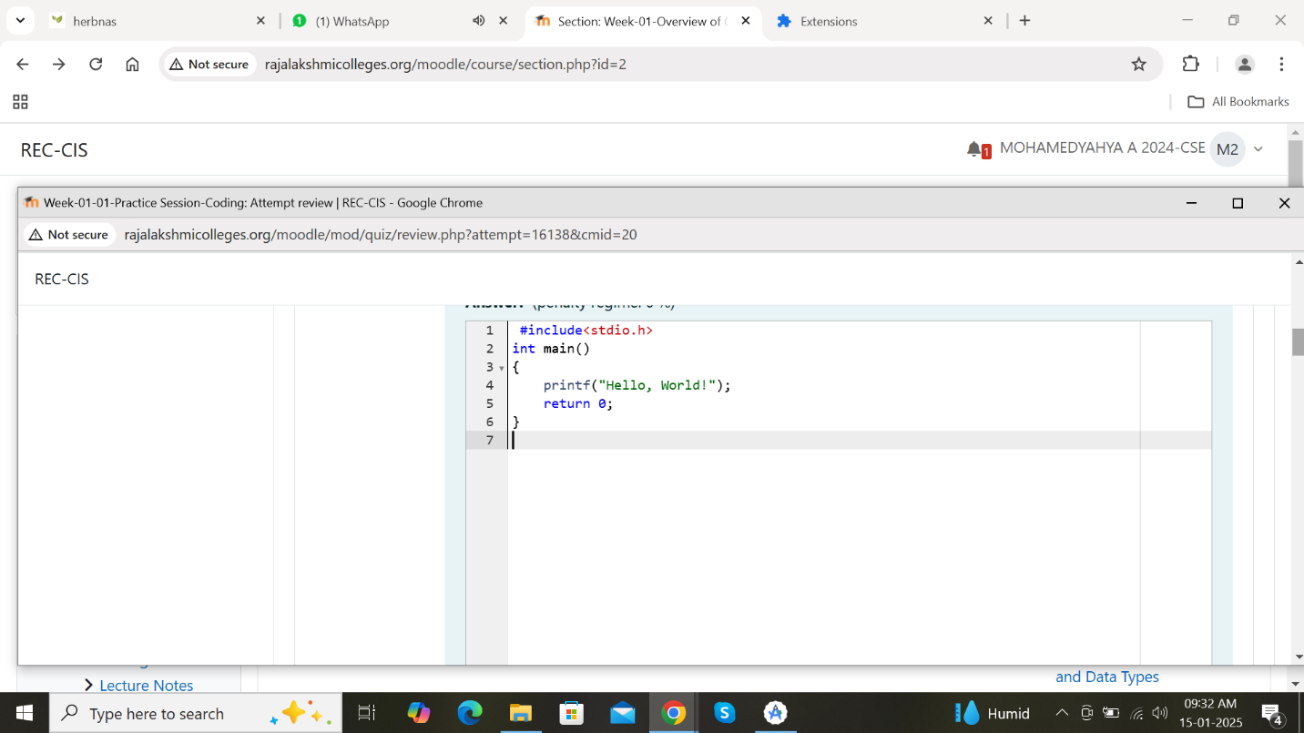

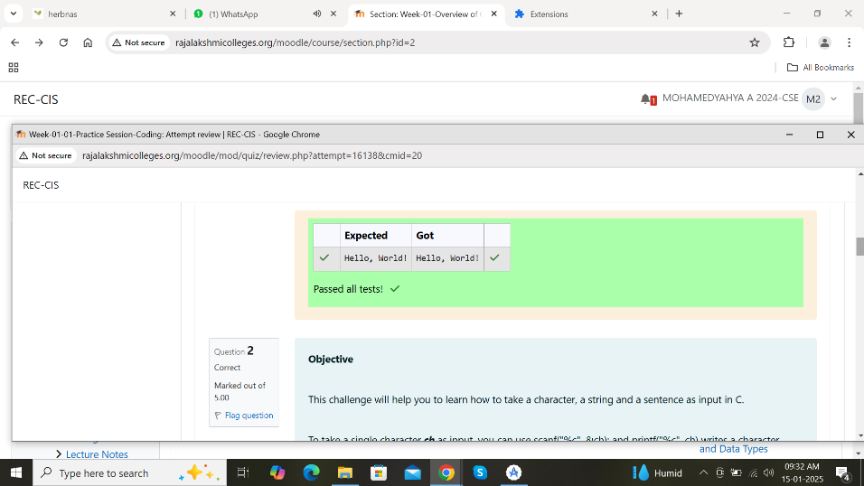

Program 2 ( 2 )

Objective

This challenge will help you to learn how to take a character, a string and a sentence as input in C.

To take a single character ch as input, you can use scanf("%c", &ch); and printf("%c", ch) writes a character specified by the argument char to stdout:

char ch;

scanf("%c", &ch);

printf("%c", ch);

This piece of code prints the character ch.

Task

You have to print the character, ch.

Input Format

Take a character, ch as input.

Output Format

Print the character, ch.

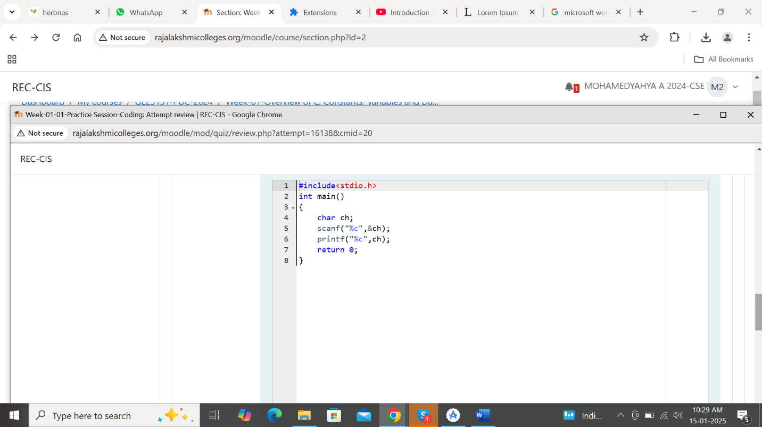

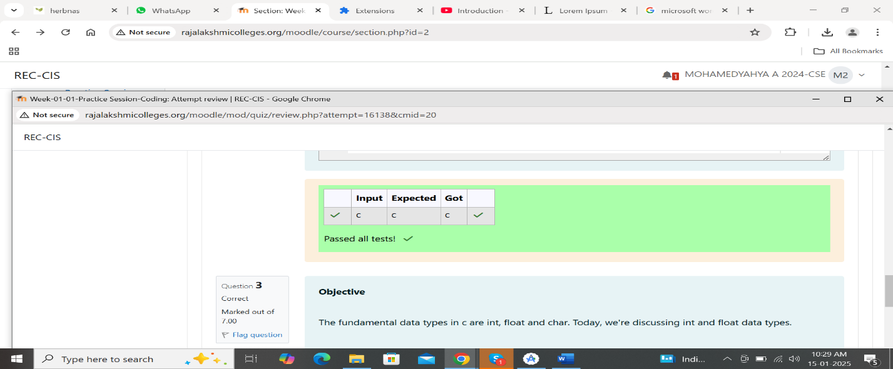

Program 2 (3)

Objective

This challenge will help you to learn how to take a character, a string and a sentence as input in C.

To take a single character ch as input, you can use scanf(“%c”, &ch); and printf(“%c”, ch) writes a character specified by the argument char to stdout:

Char ch;

Scanf(“%c”, &ch);

Printf(“%c”, ch);

This piece of code prints the character ch.

Task

You have to print the character, ch.

Input Format

Take a character, ch as input.

Output Format

Print the character, ch.

Answer☹penalty regime: 0 %)

